What is a Disaster Response Coordinator?
The disaster response coordinator (DRC) serves as the liaison for disaster readiness and response between your congregation and your disaster response coalition to help facilitate effective COMMUNICATION and COORDINATION.
- Helping identify how you will respond
- Arranging for volunteers to serve
- Offering training for volunteers
- Forming a disaster response team
Coordination

The DRC coordinates your congregation’s participation in disaster response by...
- Following communication from your coalition
- Connecting with your coalition’s leadership
- Sharing information with your congregation
- Participating in periodic DRC meetings
Communication

The DRC acts as the key contact between
your coalition and your congregation by...

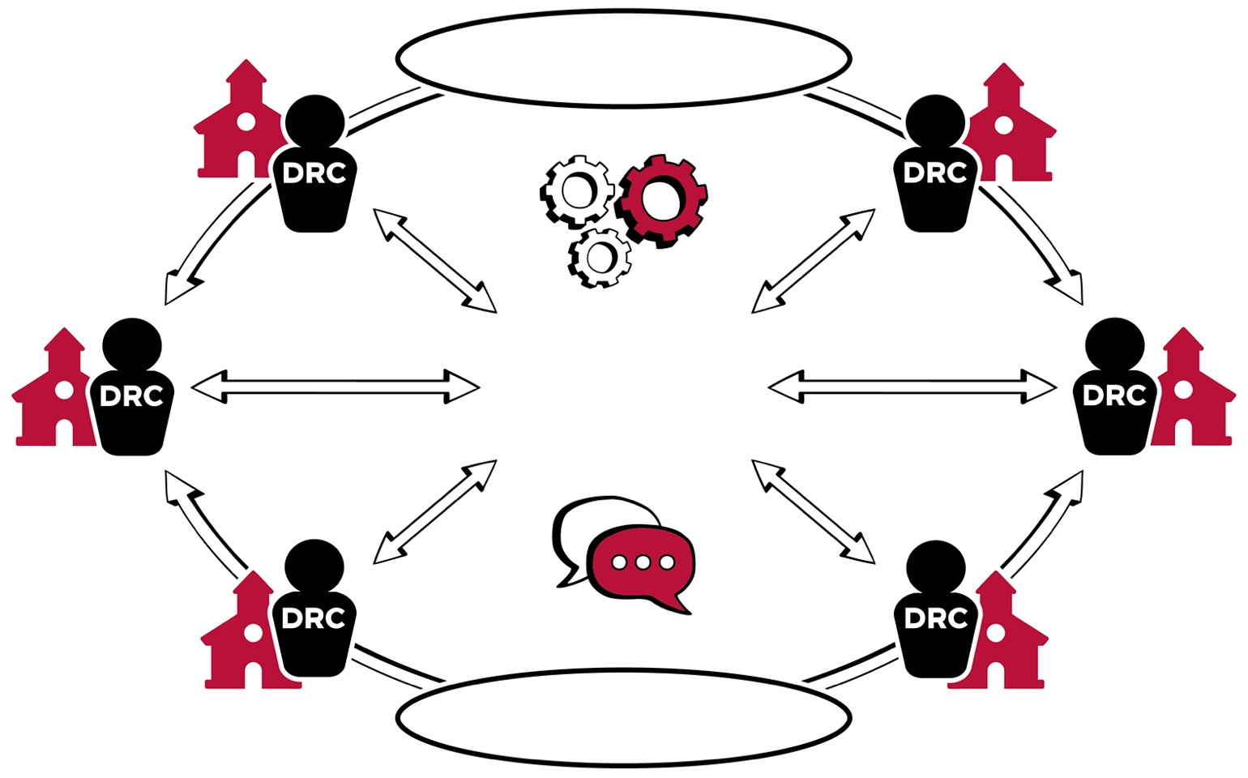
Communication
Coordination
DISASTER
RESPONSE
COALITION

