Handguide for Recruiting Volunteers
One Solution for Maintaining Operational Momentum in Disaster Recovery

Purpose
The purpose of this document is to help Coalition Volunteer Managers specifically recruit senior volunteers from local churches. The idea that believers from local churches serve in disaster relief and recovery is consistent with the Houston Responds premise that the people living in a community affected by a natural disaster should be helped primarily by the local church.

This premise is consistent with the Biblical mandate for believers to:
- Bear one another’s burdens – Galatians 6:2
- Visit others in their affliction – James 1:27
- Serve the least of these – Matthew 25:31-40
- Lay our lives down for others – John 15:13
- Cross to the other Side of the road – Luke 10:30-37

Background
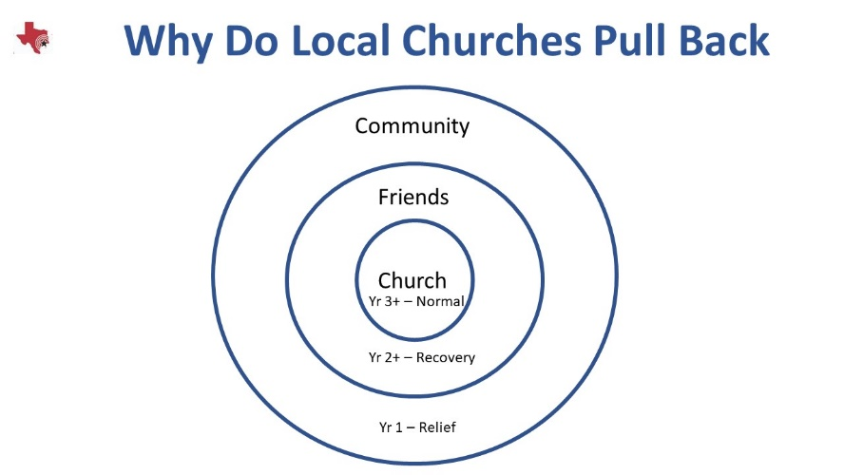
In the period immediately after a disaster, the local church congregations are intensely aware of the need for help in their community. Many have been personally affected and most will likely know families outside of the congregation who were affected as well. Many churches mobilize to provide assistance, shelter, food, water, clothing, and debris removal. Some continue after the relief period, up to the first year after the disaster, and organize for the recovery. But, eventually, the congregations’ focus shifts and they want their church to get back to “normal”. By year two, the money raised to help with rebuild has been exhausted. There are still many people in need, but the local churches involvement and awareness of continued need begins to wane.

It is at that point where the para-church ministries role becomes even more crucial. Keeping the local churches involved in the recovery is a challenge. Out of state volunteers often have shifted focus to “fresher” disasters. It is no longer a push where volunteers are coming in response to the need, but a pull, where volunteers are recruited by the para-church ministries.

Understanding the Local Church
Every evangelical church has a God-given mission and purpose. Each church is shaped for God’s glory and the good of the people within its sphere of influence. Some churches even have disaster relief and recovery as one of its specific, habitual, funded mission areas. Most churches do not.
As a faith-based non-profit whose purpose is to help in disasters, both relief and recovery, we come alongside the local churches and stand in the gap, in the long term – providing help where the local church is not able or willing or called to help those affected by the disaster.
Perhaps one of the greatest challenges in the disaster recovery ministry is maintaining reconstruction momentum. Our mission’s effectiveness depends upon a continuous stream of volunteers who serve. During the first months of a disaster, there is a strong commitment on the part of local and distant churches to help the helpless. Over time, priorities change and attention drifts to other opportunities. For the local church, the desire to “get back to normal” becomes dominant in church life.
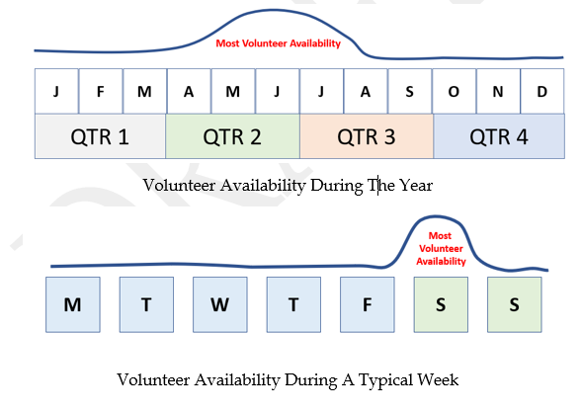

Your challenge as the Volunteer Manager is to raise the line for volunteer support for the other months and days of the week. The only way you can do that is by recruiting people who have more time available. More volunteers equate to more survivors helped and returning to their homes quicker.
Construction or reconstruction is a business process that is accomplished by thousands of workers every day. So, what makes what we do as the church differ from what well-meaning secular organizations do? By serving others, we are serving the Lord. By its nature, the spiritual aspect can be transparent by offering prayer or sharing of the Gospel. But in large measure, it is the Spirit of God who is at work behind the scenes. The workers are merely a physical manifestation of the Spiritual presence.

The added spiritual aspect is something no business or secular non-profit can do. As faith-based non-profits, we come alongside the local churches in the midst of a disaster and the confusion and pressure it brings. We do what they unable to but are careful not duplicate efforts. We don’t supplant the local church, but rather stand in the gap for them.
Ours is a Godly calling and we must be careful to not abandon our dependence upon God as the source and provider in favor of man’s schemes and processes. Those schemes and processes must always be applied in the context of the sovereignty of God.

“Men make plans in their hearts, but God orders their steps.” – Proverbs 16:9

Each Church Has the Same Root but Different Fruit
Although continued, active involvement by the local church seems reasonable and consistent with God’s will for the church, there are a number of reasons why churches fail to live up to that Biblical mandate.

The Shape of a Church’s Ministry
Each church has been gifted by the Spirit of God with God’s purpose. The use of that purpose is totally dependent upon the submission of the congregation to the will of God when the Spirit says, “This is the way; walk in it.” (Isaiah 30:21) Consider the history of the particular denomination the church represents. There are some denominations that, historically, are not involved in missions – local or foreign. Instead, they may be involved in human rights or community development, job creation, helping the homeless and destitute – not homeowners.

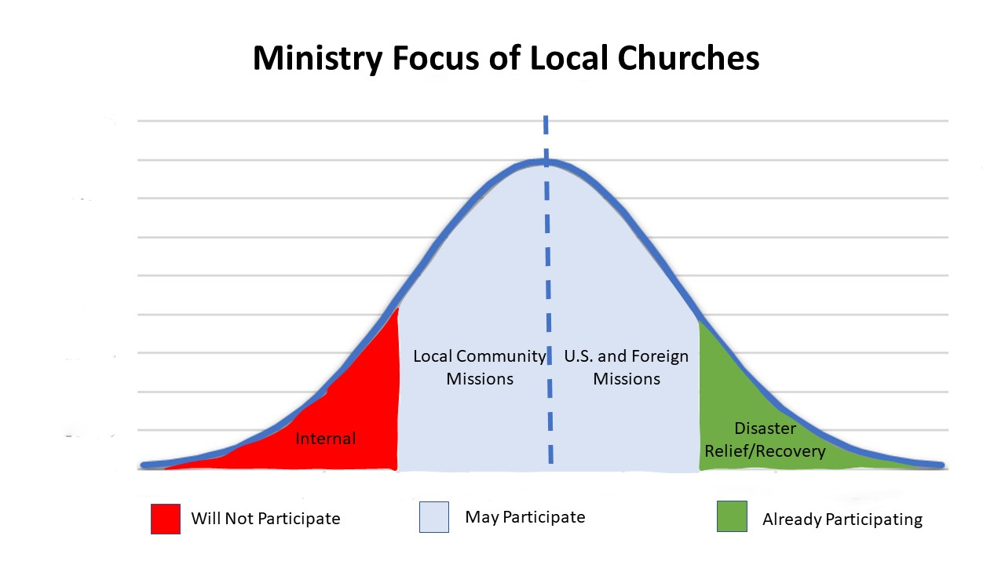

There are some churches that will never be involved in any form of ministry outreach. Their focus, for a variety of reasons, is internal.

The Scope of a Church’s Ministry
Some churches limit themselves to meeting needs within their own congregation, while others reach out into the community and other parts of the world. One church may express the love of God through local benevolence, and another may reach out to the people nationwide.

The Size of The Church
The median size of a congregation in the United States is 75 members. Based on that data, at least 50% of the churches will have a limited ability to respond in long term financial and volunteer support.

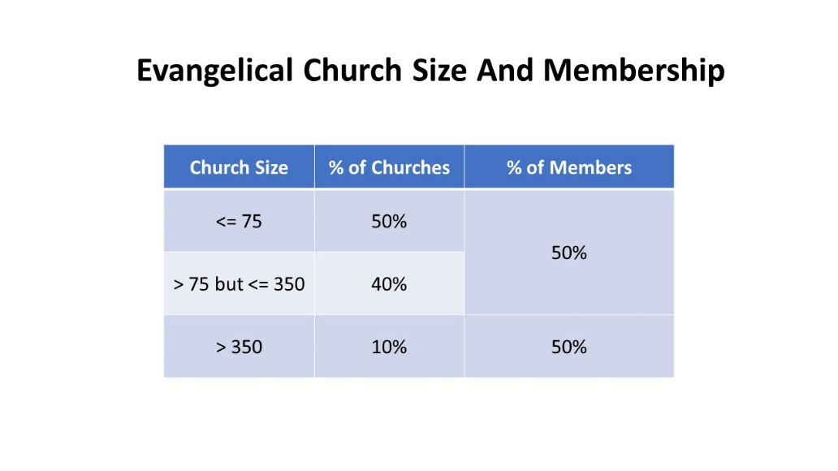

The Demographics of The Church
Demographics of the church such as gender, age, and socio-economic factors can also affect the response of each church.
One study suggests that, on average, as much as 50% of a church body is 50 years old or older. Due to the high attendance of adults over the age of 50, congregations typically have a “seniors group”.
The fact is, the “seniors” group is a vast reserve of wisdom and abilities that are typically untapped or worse, ignored. The problem is that those same seniors have been taught, long before they became a senior to expect nothing less. In fact, our American culture teaches everyone that you work until you get to a certain age, then you focus on yourself and enjoy life.
Speaking with the Minister to Seniors in a large local church, he told me that the seniors he had spoken to expect to be served, not to serve. He was taken aback by that comment and was struggling with finding the Biblical imperative for that thinking. In fact, quite the opposite was true. He said, “We are called to serve by the Spirit and are never to stop unless led by the Spirit.”

God is shaping us to be like Jesus.
“For those God foreknew he also predestined to be conformed to the image of his Son, that he might be the firstborn among many brothers and sisters.” – Romans 8:29
Jesus came to serve others not to be served.
“.. the Son of Man did not come to be served, but to serve, and to give his life as a ransom for many.” – Matthew 20:28
Serving others is a reflection and natural product of our faith.
“But do you want to know, O foolish man, that faith without works is dead?” – James 2:20
Actually, there is no age limitation on serving or ministering. That limitation does not come from God, but from man. Perhaps well intended, but very often misplaced.
Because of the factors influencing Senior participation in church ministry and missions, I have just described, there is generally a lack of opportunity for members over 55 to serve in a meaningful way, both inside and outside of the church. But not the lack of need.

Spiritual Composition and Motivation of the Church

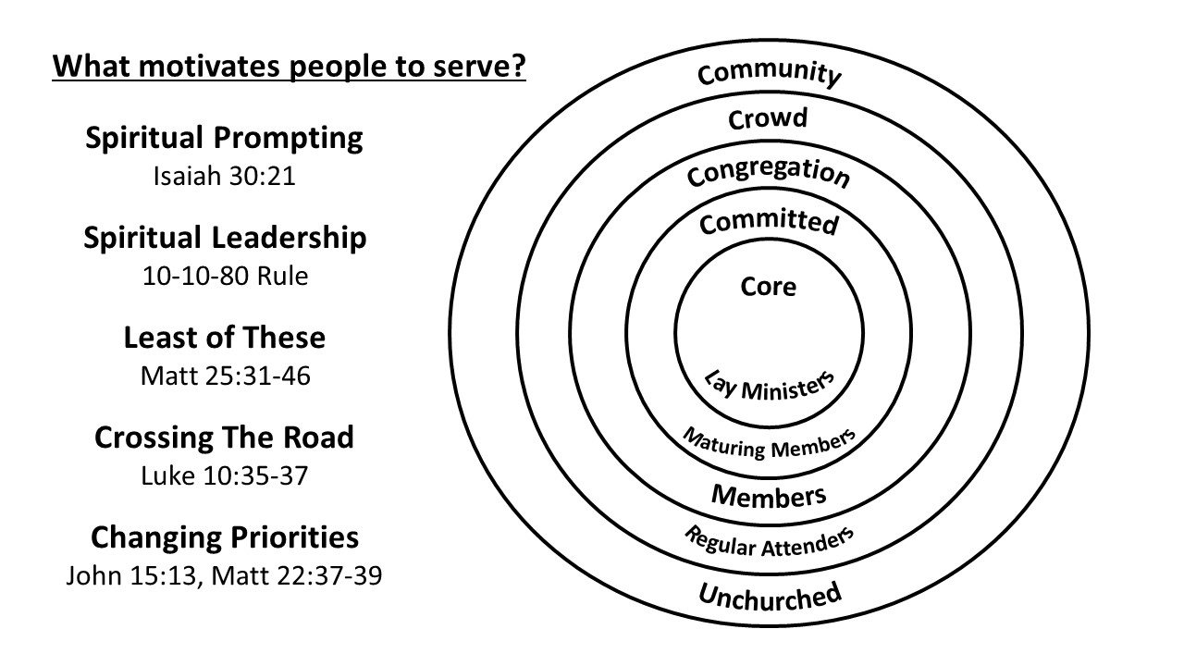
In the book “The Purpose Driven Church”, Pastor Rick Warren described the groups of people who attend church by using concentric circles. There is a great deal of variation with respect to the percent of each category of attenders. But, it is safe to say that the closer to the center, the smaller the percentage of the church attenders it represents.

In our quest to encourage local churches to actively participate in the Relief and Recovery phases of a disaster response, we must keep in mind that the essence of a church’s existence is faith and the inspiration of the Spirit of God.

The underlying premise of Houston Responds is the idea that local churches should be fully engaged in meeting the needs of the people living in their community. In their Jerusalem, Judea, and perhaps Samaria.

“Where there is no vision, the people are unrestrained, But happy is he who keeps the law.. "- Proverbs 29:18 (NASB)

There is a rule concerning participation called the 10-10-80 rule. I don’t think it is quite a natural law, but it does seem to be proven true more often than not. The rule essentially says states the 10% of a group of people will never participate – not matter how compelling the appeal. 10% of the people do not need encouragement, they are already predisposed to serving and are actively seeking opportunities to serve. You might see them serving as volunteers with a national relief organization or in some community service project. Then there is the 80%. The clear majority of people in the group. They will serve but not outside the context of relationship or leadership. Someone must cast the vision and lead the way. Without the participation and endorsement of the spiritual leadership in a church, you will not be successful in your quest to engage that church in relief or recovery.

Understanding Volunteer Participation and Discretionary Time

Senior Adults in the United States
Retirement, that is the goal of most working Americans. What that looks like largely depends upon the financial stability of the person retiring. For some it means travel. For others it means sitting on the front porch watching the cars pass by. For most it means disconnecting from the world and focusing on themselves. That is not an inherently bad thing, but it is not inherently scriptural either. The problem is that most churches promote that idea. Make room for younger Christian adults to allow them to serve and exercise their spiritual gifts. Nothing inherently wrong with that either. The thing is every Christian in the local church has something to contribute to the health of that assembly and to the ministry and mission God has ordained – irrespective of age or gender.
Recruiting senior adults may require convincing church leaders and the senior adults of those truths. So what is your part in the convincing? Your part is in the telling and the Spirit’s part is in the convincing or convicting. Not everyone will embrace the idea of not taking the trip or getting off of the porch, but you don’t need everyone – just those that the Spirit has promoted to step up and serve. For younger people, their argument for not serving is that they don’t have the discretionary time to do it. For seniors their argument is that they don’t have the physical capacity or inclination to do it. Both might be right in their thinking, but there are those who choose to limit their service – for the wrong – self-serving reasons. That may sound harsh – it is not intended to be “mean” – just truth. You won’t be able to tell the difference, but the Spirit can. That is why you must be the messenger and let the Spirit be the motivator. The senior workforce is a sleeping giant that needs to be awakened.

How To Recruit Church Members With Discretionary Time

Use the same approach as recruiting all volunteers.
All adult church members are the same, spiritually. They all have the Spirit of God in them. They all share the same call to serve one another and love one another. But there are distinctive aspects of their lives that make them unique. You need to be sensitive to those distinctives.

For Senior adults some of those distinctions might be, but are not limited to:
- Physical strength
- Medical considerations
- Mobility
- Dexterity
- Spiritual Depth
- Work Experience
- Stamina

Pastor Support
The entry point for most churches is through the Pastor. Depending upon the size of the church, it might be the senior pastor or one of the assistant pastors, such as the missions pastor. If you do not have the support of the pastor, you will not have the support of the people. If the Spirit of God has gone ahead of you, then you will find favor with the pastor and the leadership. If not, move on. Not all churches will embrace you or your mission.

Meet with Key Person from Local Church
More than likely you will be asked to coordinate and communicate with a lay leader in the church. Houston Responds refers to that person as the Disaster Relief Coordinator (DRC). That is more a description of their function than a title for a position in the local church. They may not refer to themselves as a DRC, and I would suggest that you follow their lead. We are not in the business of telling a church how to organize and staff.

The key person should be someone who has a passion or interest in helping people repair their homes. That person will be your advocate. They will know men and women who have a heart or passion for helping others. This person must:
- Be Recognized by Church Leadership
- Understand the Role of the Local Church vs Parachurch Ministries
- Be aware of current rebuild needs in community
- Meet with church members interested in rebuilding ministry
- Meet with other DRC’s and the coalition Volunteer Manager
- Participate in the Rebuilding

Get in front of the people you want to recruit

You should ask for permission to speak to Bible Study classes, men’s groups, and people they know who have an interest in serving to meet for one hour. Right after church is the best time since the people are already present, but it might be on an evening during the week. During that hour you will cast the vision for the help needed.

Tell the Story
Explain who you represent – What your ministry does. Do you think of your coalition as a ministry? Remind them that you are not a construction company looking for free labor.
Speak To The Spiritual Context – Season your presentation with Biblical references to God’s call for us to serve. Emphasize the spiritual nature of the work. Depend upon the Spirit of God to speak to hearts. Your part is to share the need – plant the seed. God will bring the increase.
Speak To The Importance Of The Local Church – Emphasize the importance of the local church in reaching the community for Christ.
Share What God Is Doing Through Volunteers – Serving makes a difference in the life of the one serving as well as the one who is being served. Show a video or pictures of senior volunteers serving in different capacities.
Share Stories About The Plight Of Homeowners – Not in some other place, but in their community. How the people were affected and glory stories about how people were helped.
Share How They Can Help – Talk about what the need is today and describe how they can get involved.
- Work: 1-2-3 days at a time – You can fit them in
- Work Hours: 4 -5 hour work days – Avoid heat of the day
- Skills Required: Any skill level – Give Examples of Low Skills
- For The Untrained: Provide training – What – When – Where
- Equipment Provided: tools – including things like dry wall lifts and ladders with wide steps – of course they can bring their own personal tools.

Talk about the work of other NGO’s
Southern Baptist Disaster Relief, United Methodist Committee On Relief (UMCOR), Lutheran Disaster Response (LDR), 8 Days of Hope, Samaritan’s Purse, Hands and Hearts, Habitat for Humanity.
Know what those organizations have done and what they are currently doing in Houston.
Some of the people you meet may already be affiliated with a national or international disaster relief organizations. You are not asking those people to abandon their affiliation. But you should ask them to consider helping locally when they are not actively working with a particular NGO (non-governmental organization).
Those disaster relief organizations look to the local church for support, both financially and with respect to volunteer labor. They are very effective in what they do and how they recruit support.

There are only so many people in a given church that have a passion for disaster relief work. You are entering the scene as a late comer. It is important that you respect those ministries and not be seen as someone who is encouraging churches to “steal sheep”! Robbing Peter to pay Paul, if you will. Volunteer involvement with your coalition’s work is through the local church. They represent their local church not your organization.

This is not a competition. Those ministries typically engage in disasters for a season. Volunteers are engaged for one or two weeks at a time. What you are promoting is the local church being involved in ministering to the local community on a continual basis. Until the work is done. That may mean that if volunteers are involved in the local church outreach and the national level organizations, they should be encouraged to not seen their involvement as mutually exclusive.

Feedback To The Churches
You must provide periodic feedback to the churches who provide the volunteers so they have some idea of the value of their participation. Information like who served, who they served, and what they accomplished. You should coordinate who you send the report to and by what means, e-mail, letter, personal visit with each church.

Ask people to sign up or at least pray about volunteering
The church may not be willing to dedicate ministry resources - a leader/DRC or money to this – but may be willing to facilitate the coalition engaging with its members who are interested in serving on behalf of the church either directly or through a key person.

Managing Volunteers with Discretionary Time
So what will the teams look like? You should not expect any one church to provide all of the people you need for a rebuild. In all probability, you will recruit a few people with various skills from each of several churches. Volunteers from the same church may want to work together, but your work teams will most likely be comprised of volunteers from different churches.
It will be your responsibility to schedule their work during the week. To contact the volunteers and follow-up the day before they are to report for work. The team composition will most likely be “ad-hoc” in that the members will not be the same, even day to day. It will be the responsibility of the coalition site leader to organize the work each day. Success will require close coordination and planning between the volunteer manager and site leader.

Sample Registration Form

Church ____________________
First Name___________________________________
Last Name___________________________________
Home Address________________________________
City_________________________________________
State________________________________________
Zip________________ Age __________ Gender (M/F) _________
Mobile Phone (____)______________ Email Address: ____________________
Physical Limitations: ____________________
Medical Considerations: _________________
Days available (Circle All That Apply) |  | M |  | T |  | W |  | T |  | F |  | S

Skills/Equipment/Tools (Electrical, Carpentry, Plumbing, Roofing, Etc.)
Skill | Experience | None | Some | Handy | Experienced | Expert

Electrical
Framing
Finish Carpentry
Flooring
Cabinets
Plumbing
Roofing
Helper
Other (explain)
Explanation:

